Adolfo T. Javier Leon
Final Forensic Case Report – Phase 4
- Executive Summary (Non-Technical)
The forensic investigation report was prepared to determine whether malicious activity occurred on the targeted system following a user's interaction with the YouTube.com link. A complete forensic plan was executed, including evidence acquisition, disk image analysis, and network traffic review. The main goal was to identify any indicators of compromise (IOC), unauthorized activity, or malware.
There were two pieces of evidence collected based on a full disk image and network traffic capture. These actions were executed using forensic procedures and verified by their hash values to ensure integrity. The analysis focused on identifying suspicious files, unusual network activity, or artifacts that may contain malware.
The investigation revealed no evidence of the system being compromised. There were recovered files from the disk images that were benign, with no malicious executables, scripts, or persistence mechanisms identified. Network traffic was associated with the YouTube link, showing normal homepage access, with additional preview videos and content retrieval, with no connection to suspicious domains or IP addresses.
Based on the evidence, the system did not experience any security breach or malware infection. The activity was observed to have had consistent access to YouTube content, but overall, the impact assessment was null, and no action was required.
- Incident Overview
The investigation started with a user accessing a YouTube link that was believed to be potentially suspicious. Although no malicious malware or phishing was found at the time of access, the purpose of the investigation was to verify whether any compromise occurred and to ensure the integrity of the system, confirming that no unauthorized activity was taking place, and validating the integrity of the system. The scenario reflects a common real-world situation that can be caused by misleading ads, or unauthorized links, interactions online, and a forensic review is conducted out of caution rather than in response to confirmed malicious activity.
  - Timeline:
    - User Activity
      - The user accessed a YouTube link and reported concerns regarding potentially suspicious behavior.
    - Evidence Acquisition
      - Using the disk image tools (E01) and live network capture (PCAPNG), data were acquired from the targeted system using the industry-standard forensics tools.
    - Forensic Examination
      - The disk image and network capture were analyzed using Sleuth Kit, Strings, Hashdeep, and Wireshark, are used to identify suspicious files, network anomalies, or indicators of compromise.
    - Case Reporting
      - Findings were documented and consolidated into this final forensic case report
- Evidence Summary
  - Disk Image (E01)
    - The disk image was acquired by using Guymager on the targeted machine to make a forensically sound bit-for-bit copy of the image. The image was saved in Expert Witness Format as E01 and automatically segmented into multiple files like “kali_disk_image.E01 through kali_disk_image.E06”, along with a metadata file, “kali_disk_image.info”
    - Hash value
      - MD5
        - 82a022bfed3fff6800693947f058378f
      - SHA-256
        - f60bba51c5e743c41eac77c8af068d3257de53fd5ac71686bf1cb98739ab992
    - Acquisition Date/Time
      - 05/02/26 4:12 PM EDT
    - Chain of Custody
      - The disk image was acquired using a read-only workflow. Guymager automatically generated MD5 and SHA-256 hashes during acquisition, which were verified immediately after imaging. The image was stored in “/home/adolfo/ForensicsLab/Evidence”. No modifications were made after the acquisition.
    - Tools
      - Guymager
      - Hashdeep
      - Linux File Utilities
  - Network Capture (PCAPNG)
    - The live capture was performed on the targeted machine on which a user interacted with a YouTube link. The result was a PCAPNG file called “network_capture_youtube_ping.pcapng”, containing HTTPS traffic, ICMP packets, and DNS queries associated with the YouTube content page.
    - Acquisition Date/Time
      - 05/01/26, 12:15 AM EDT
    - Chain of Custody
      - The PCAPNG file was captured using Wireshark, and after that, it was transferred to the evidence directory after obtaining it. No hash values were generated for the network capture at the time of acquisition; no alterations were made after acquisition.
    - Tools
      - Wireshark
      - Linux file utilities
- Methodology
  - Tools
    - Wireshark
      - Wireshark was chosen for deep packet inspection and network correlation. Since it enabled detailed analysis of ICMP, DNS, and HTTPS traffic captured during the user’s interactions with the YouTube links.
    - Sleuth Kit
      - Sleuth Kit was chosen because Autopsy failed to run. and TSK provides complete command‑line access to the file system, allowing enumeration of directories, metadata extraction, and recovery of deleted files.
    - Strings
      - Strings utility was chosen for rapid triage of binary artifacts, allowing extraction of readable text from DLLs and other binaries to identify suspicious content, embedded URLs, or hidden commands.
    - Hashdeep
      - Hashdeep was chosen for integrity verification and hashing consistency. It was used to generate the MD5 and SHA-256 hashes for extracted files and to confirm the integrity of the disk image.
    - Linux File Utilities
      - Linux file utilities were chosen since they were already in the system, and for safe, read‑only navigation and artifact extraction. Tools were mostly used for file support identification, metadata review, and accessing other types of raw, E01, info, and PCAPNG evidence files.
  - Evidence processed
    - Mounting the Disk Image
      - The E01 image was mounted in read‑only mode to prevent modification of the original evidence, consistent.
    - File System Enumeration
      - Sleuth Kit commands (fls, istat) were used to identify files, directories, and metadata.
    - Artifact Extraction
      - Relevant files (DLLs, logs, browser artifacts) were extracted using icat and stored in an analysis directory.
    - Hash Verification
      - Hashdeep was used to generate and verify hashes for extracted files and confirm the integrity of the disk image.
    - Terminal Binary and Text
      - The strings tool was used to inspect DLLs and other binary artifacts for suspicious content.
    - Network Traffic Review
      - Wireshark was used to analyze DNS, ICMP, and HTTPS traffic captured during the user’s interaction with the YouTube link.
    - Cross-Evidence Correlation
      - Disk artifacts and network events were compared to determine whether any suspicious activity spanned multiple evidence sources.
  - Deviations from standard procedure
    - Attempted to use Autopsy, but the tool was not compatible with the targeted system because it was outdated. As a substitute, Sleuth Kit command-line tools were used instead. The deviation did not affect the investigation, as the Sleuth Kit provides full access to file system structures and is widely accepted across most systems.
- Detailed Findings
  - Suspicious files, processes, or artifacts
    - Recovered DLL files
      - The file system analysis showed that several DLL files, including previously deleted DLLs, were recovered using the Sleuth Kit icat tool and examined to determine whether they contained malicious code or unauthorized modification.
      - Evidence
        - DLL (Appendix H-3)
        - Strings (Appendix H‑5)
        - Hash Value (Appendix H‑7)
      - Interpretation
        - The recovered DLLs contain only benign system strings, including SMTP error messages and standard library references. No malware or suspicious behavior was identified.
      - Relevance to the Incident
        - Even though the DLLs can be used for persistence or injections, this behavior can be benign and unrelated to the YouTube activity, with no suspicious files found on the system.
  - User activity (downloads, browsing, command history)
    - Browser Activity Analysis
      - Browser artifacts were examined to determine what content the user accessed at the time of the suspected incident.
    - Evidence
      - Firefox places.sqlite strings (Appendix H‑5)
      - Wireshark DNS/ICMP packets (Appendix H‑6)
    - Interpretation
      - The Firefox database contained normal browsing behavior. The network capture showed the user accessed the YouTube homepage and related content delivery servers. No downloads, redirects, or suspicious browsing activity were identified.
    - Relevance to the incident
      - User activity was consistent with normal YouTube usage and did not indicate compromise.
  - Registry or configuration changes
    - Description
      - System configuration files and metadata were reviewed for unauthorized changes or persistence mechanisms.
    - Evidence
      - EXT4 metadata fsstat (Appendix H‑4)
      - GParted (Appendix H‑1)
    - Interpretation
      - The EXT4 metadata showed normal mount times, inode counts, and journal structure. No suspicious configuration changes or unauthorized modifications were detected.
    - Relevance to the Incident
      - Confirms that the system configuration remained intact and was not altered by any malicious activity.
  - Network anomalies
    - The PCAPNG file was analyzed to identify unusual or suspicious network behavior.
    - Evidence
      - Wireshark DNS queries + ICMP echo requests (Appendix H‑6)
    - Interpretation
      - All network traffic was consistent with normal YouTube usage. No anomalies, beaconing, or malicious communication patterns were observed.
    - Relevance to the Incident
      - Supports the conclusion that no malicious network activity occurred.
  - Persistence mechanisms
    - The system was examined for persistence mechanisms commonly used by malware.
    - Evidence
      - File system metadata (Appendix H‑4)
    - Interpretation
      - No persistence mechanisms were found. The system showed no signs of malware attempting to maintain access.
    - Relevance to the incident.
      - Confirms that no malware attempted to persist on the system.
  - Correlation across evidence sources
    - Artifacts from the disk image and network capture were correlated to determine whether any suspicious activity spanned multiple evidence sources.
    - Evidence
      - Hashdeep (Appendix C‑7)
      - Guymager (Appendix C‑2)
    - Interpretation
      - Both evidence sources independently support the conclusion that no malicious activity occurred. Hash values matched across acquisition and verification, confirming evidence integrity.
    - Relevance to the Incident
      - Correlation confirms that the user’s interaction with the YouTube link did not result in compromise.
- Timeline Reconstruction
  - File system events
    - 05/02/26 4:07 PM EDT - 05/02/26 08:19 PM EDT
EXT4 Last Written Time and Last Mount
        - Source: fsstat output
        - The file system wrote data at 4:07 PM and was last mounted at 8:19 PM.
        - No abnormal or unauthorized file modifications were detected.
        - The system was mounted normally, with no current evidence of forced, unsafe, or unexpected mounts.
    - Recovered File Events (DLLs)
      - DLLs recovered using icat (inodes 864942, 865083, 1469402)
      - Strings analysis showed only benign system content
      - No malicious file creation or modification timestamps were identified
  - Network activity
    - 05/01/26 12:15 AM EDT
      - Network Capture Begins (PCAPNG)
        - User interacts with a YouTube link.
        - Wireshark begins capturing DNS, ICMP, and HTTPS traffic.
      - DNS Activity
        - Queries:
          - youtube.com
      - ICMP Activity
        - User manually sends ICMP echo requests (ping).
        - Normal echo replies received.
      - HTTPS Activity
        - Encrypted traffic to YouTube content servers.
        - No redirects, no suspicious IPs, no anomalies.
  - User actions
    - 05/01/26 12:15 AM EDT
      - The user opened the YouTube link, triggering the network capture
      - No redirect or malicious link found
    - Browser Activity
      - places.sqlite string showed normal browsing metadata on the Firefox browser
      - No evidence or suspicious browsing found
    - Evidence File Recovery
      - Recovered DLLs were system files, not user-created
      - No user-initiated file modifications related to malware
  - Malware execution
    - No malware was detected, and after checking the evidence sources, there was nothing on the system; no suspicious process, executable, or persistence mechanisms were identified.
- Conclusion and Assessment
  - What happened
    - A forensic investigation began due to a user’s frequent use of a YouTube link, which was believed to be a potential malware risk. Since then, a full disk image analysis (E01) was performed, and a live network capture (PCAPNG) was acquired and analyzed using Sleuth Kit, Hashdeep, strings, and Wireshark. The goal was to verify that the system was not compromised by unauthorized activity or malware. The investigation found no evidence of compromise, no malware, and no authorized system changes, making it an activity that was consistent with normal YouTube access.
  - How the compromise occurred
    - No compromise occurred; the YouTube link accessed by the user was harmless, with no redirect to malicious domains, no triggered downloads, or execution of any harmful code.
  - What evidence supports the conclusion
    - The conclusion is supported by multiple pieces of evidence, which are
      - Disk image
        - Recovered DLLs contained only benign system strings, with no malicious executables or scripts identified. The EXT4 metadata showed normal mount and write times, and no unauthorized configuration changes or persistence artifacts were detected.
      - Network Capture
        - Using Wireshark was easy to identify the DNS queries of the website links, confirming that its legitimate YouTube/Google domains, HTTPS traffic was consistent with normal video loading. ICMP traffic is manually initiated by the user, with no suspicious IPs or anomalies in the traffic.
      - Hash Verification
        - Guymager acquired the Hashes, primarily MD5 and SHA-256, that matched. Hashdeep confirmed this through verification of disk image integrity with no evidence of tampering or modifications.
      - Browser Evidence
        - Checking the web browser, using places.sqlite showed normal browsing data. With no additional downloads, redirects, or suspicious URLs.
  - What actions should be taken (containment, remediation, monitoring)
    - Even though there was no malicious activity, the following actions are recommended as per standard practice
      - Monitoring the network traffic and browser activities
      - Educating users on identifying suspicious links
      - Not opening any links that are not from official domains
  - Confidence level in findings
    - My confidence level is high because I verified everything thoroughly using the Disk image integrity and network capture integrity, along with multiple forensics tools. The results were consistent across all the evidence sources with no indicators of compromise. With the absence of malware, suspicious activity, unauthorized changes, and abnormal network behavior, the system is not compromised.
- Appendices
  - Full command logs
    - Disk Image Analysis
      - mmls kali_disk.raw.raw
      - fsstat -o 2048 kali_disk.raw.raw
      - fls -o 2048 -r kali_disk.raw.raw
      - icat -o 2048 kali_disk.raw.raw 864942 > recovered_864942
      - icat -o 2048 kali_disk.raw.raw 865083 > recovered_865083
      - icat -o 2048 kali_disk.raw.raw 1469402 > recovered_1469402
      - strings recovered_864942
      - strings recovered_865083
      - strings recovered_1469402
      - /home/adolfo/.mozilla/firefox/2twx3l4r.default-esr/places.sqlite
    - Network Capture Analysis
      - Sudo Wireshark
      - Ping -c 4 youtube.com
    - Hash Verification
      - Md5sum kali_disk.raw.raw
      - Sha256sum kali_disk.raw.raw
      - Hashdeep -r kali_disk.raw.raw > hashes.txt
      - Head hashes.txt
  - screenshots
    - Phase II
      - GParted disk identification
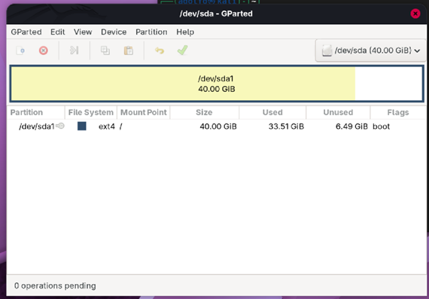
      - Guymager acquisition Report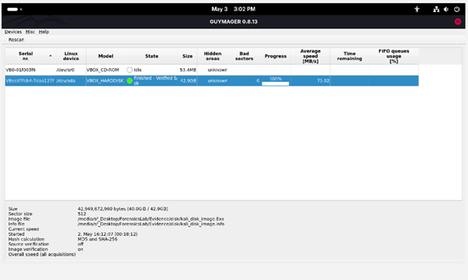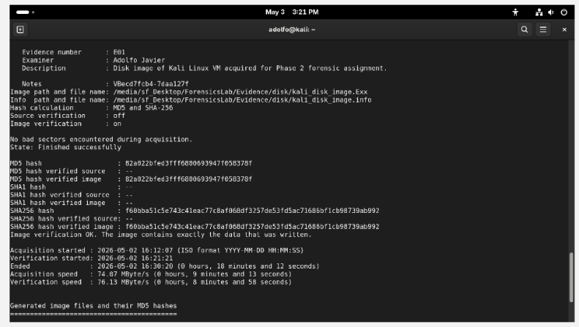
    - Phase III
      - File system metadata
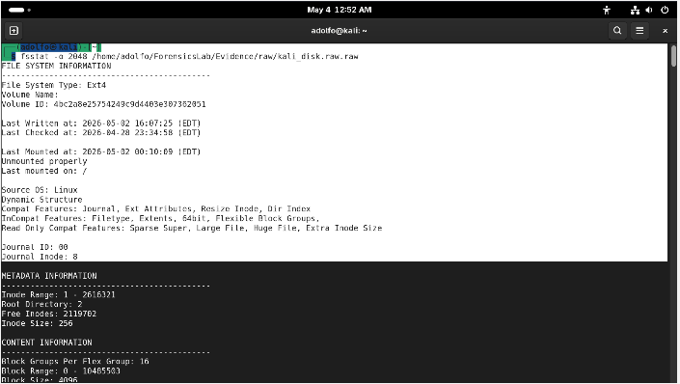
      - Analysis Evidence
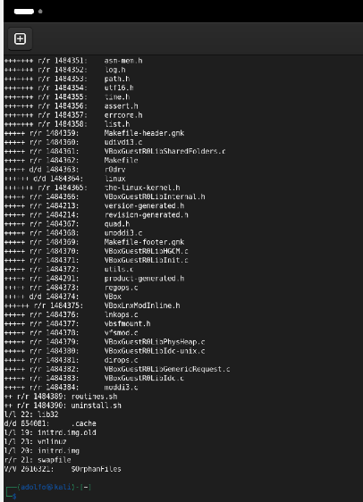
      - Recovered DLL Extraction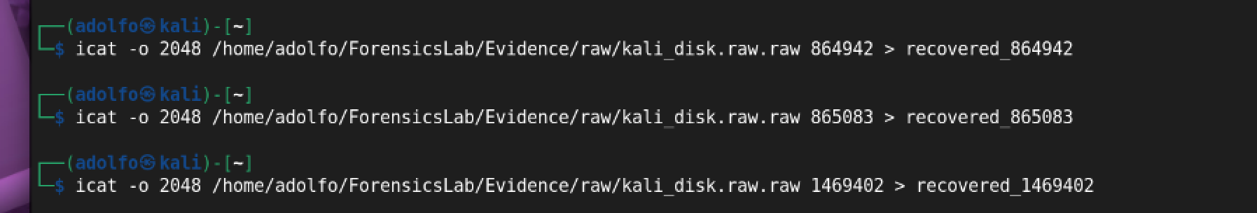
      - EXT4 metadata from fsstat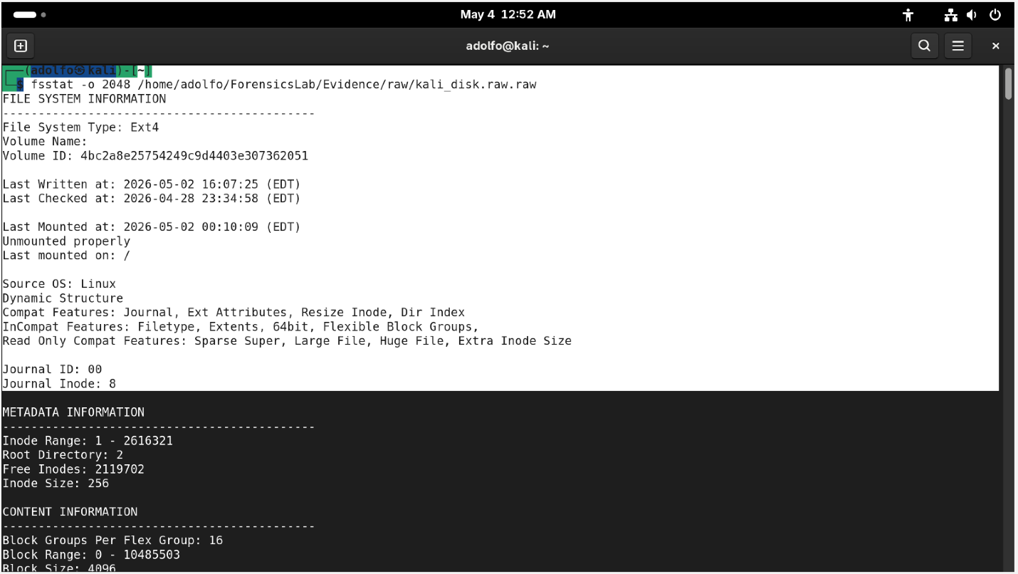
      - Firefox places.sqlite Strings Output strings 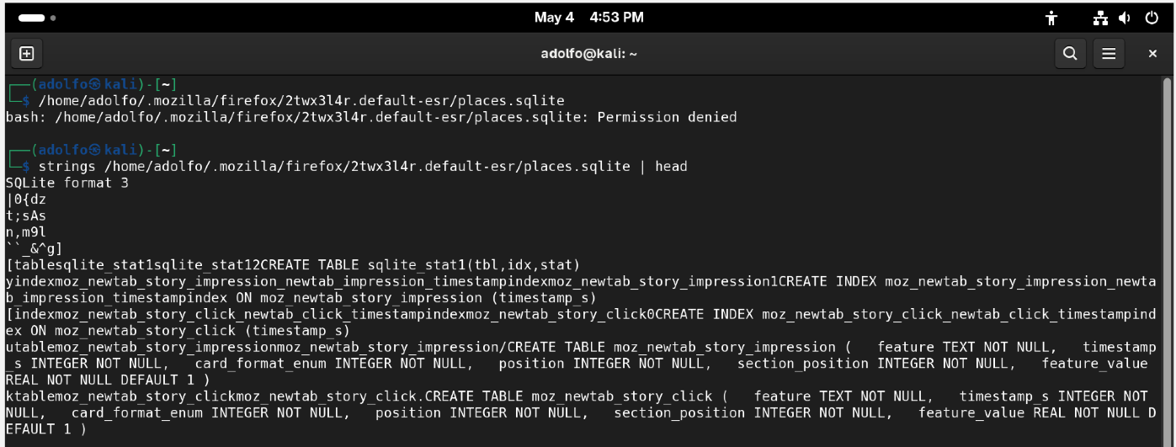
      - Wireshark DNS Query and ICMP Echo request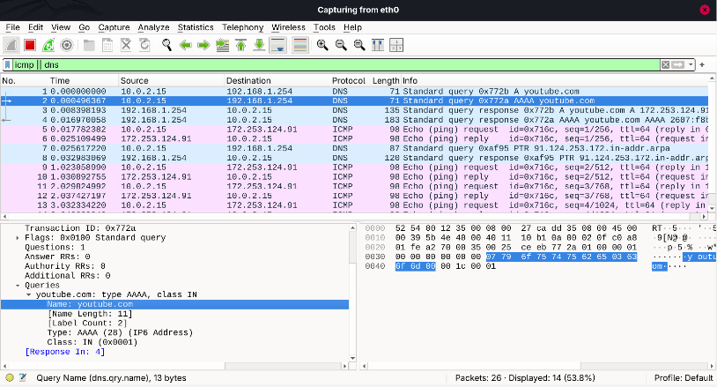
  - Extracted artifacts (non-sensitive)
    - Recovered DLL files
      - 864942
      - 865083
      - 1469402
  - Hash verification logs
    - Hashes.txt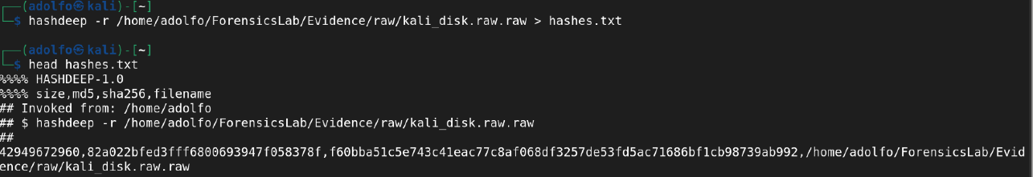
  - Tool versions
    - Sleuth Kit ver 4.14.0
    - Guymager ver 0.8.13
    - Wireshark ver 4.6.4
    - Hashdeep ver 4.4
    - Kali Linux ver 6.19.11

